MACRO PROJECT – I

Milestone 5
Complete Platform Finalization, Live Assessment & Production Readiness
Submitted By: -
Aakanksha Vidushi Pandey (BTAI25O1001)
Dhruv Urmaliya (BTAI25O1052)

Under the Guidance of: -
Dr. Neelam Arya



CENTRE FOR ARTIFICIAL INTELLIGENCE
Madhav Institute of Technology & Science
Gwalior – 474005 (MP)
July – December 2026

1. Milestone Overview
Milestone 1 established the pose-detection foundation using YOLO26-Pose. Milestone 2 extended this to movement analysis for Sit-ups, Sit & Reach, and Vertical Jump. Milestone 3 added scoring, calibration, and results display. Milestone 4 transformed this into a full multi-user platform with PostgreSQL, Google OAuth, and multi-trainer support.
Milestone 5 is the final milestone that completes the project as a production-ready product. This milestone covers:
- Complete UI/UX redesign across all 15 pages with dark mode support
- Live browser-based assessment using getUserMedia + backend YOLO inference
- Celery + Redis asynchronous frame processing (faculty recommendation)
- Trainer-level access control validation (faculty recommendation)
- Reports analytics page with team-wide statistics
- CSV export functionality
- Search and filtering on dashboard
- Athlete edit/delete operations
- Manual Height & Weight entry form
- Custom 404 and 500 error pages

Milestone 4 = Multi-User Platform → Milestone 5 = Production-Ready Product

2. Milestone 1 Baseline
Component | Milestone 4 | Milestone 5
Login/Signup | Working | Redesigned + Dark Mode
Logout | Basic | Custom View + Proper Redirect
Trainer Dashboard | Functional | Redesigned + animations
Athlete Detail | Basic | Premium with score ring + charts
Exercise Selection | Command - based | Live assessment + command modal
History | Working | Table + CSV export
Reports | Not implemented | Complete analysis
Dark Mode | Not Present | Full support with persistence
Live Assessment | Not Present | Browse Camera + YOLO
Async Processing | Not Present | Celery + Redis
Access Control | Partial | Rigorously validated (17 tests)
404/500 Pages | Default Django | Custom branded
CSV Export | Not Present | Implemented
Search/Filter | Not Present | Implemented
Athlete CRUD | Partial | Complete
Manual Height/Weight | Not Present | Form implemented

3. Objectives
- Complete UI/UX redesign across all 15 pages with consistent design language
- Implement dark mode with persistent theme via localStorage
- Build custom 404 and 500 error pages
- Create Reports analytics page with team-wide statistics
- Add CSV export functionality
- Implement search and filtering on dashboard
- Add athlete edit and delete operations
- Add manual Height & Weight entry form
- Implement browser-based live assessment for all 8 exercises
- Address faculty recommendation: Celery + Redis async processing
- Address faculty recommendation: rigorous access control testing
- Ensure mobile responsive design
- Fix authentication flow (logout redirect)
4. System Architecture

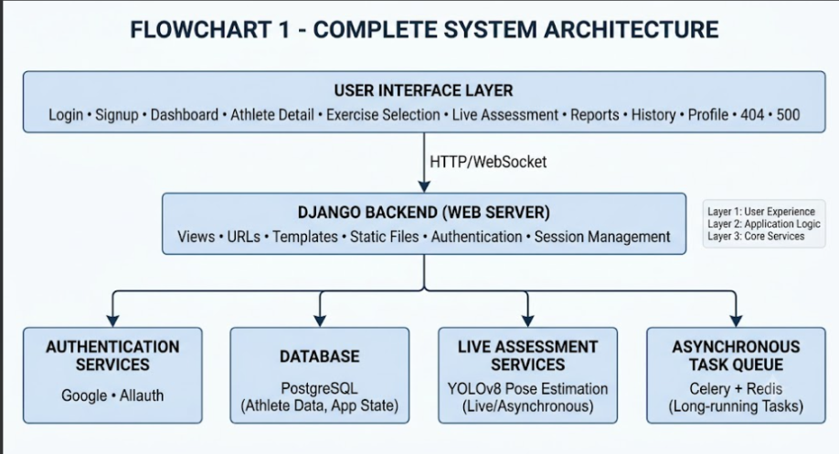

5. Trainer & Athlete Relationship

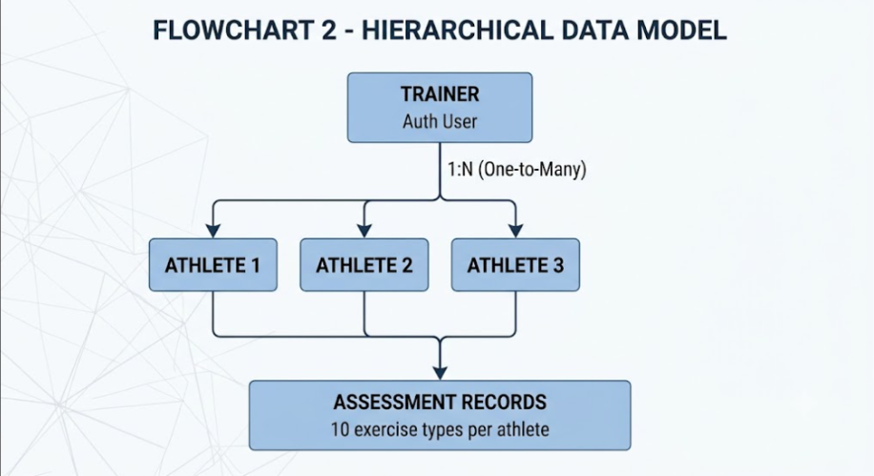

6. Database Design

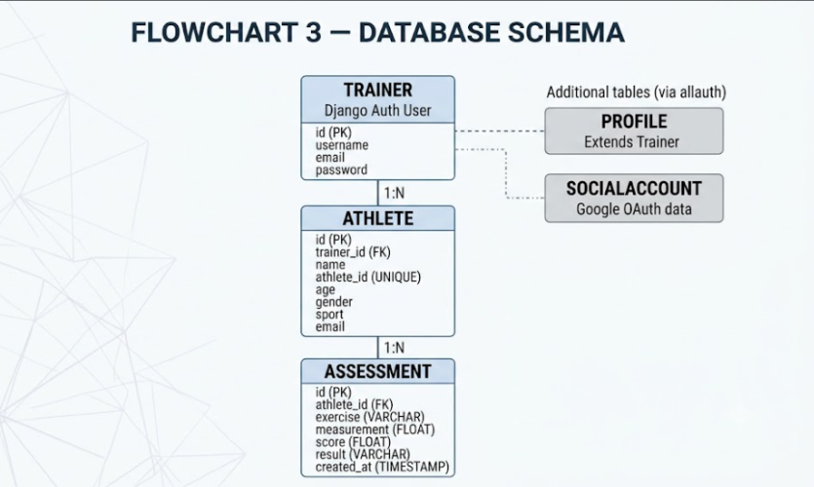

7. Authentication

Trainer authentication supports two methods: username/password and Google OAuth.

Username/Password: Django's built-in authentication verifies credentials against the stored hashed password.

Google OAuth: The trainer clicks "Sign in with Google", a popup opens with Google's official login screen, the trainer selects an account and grants permission, and the OAuth callback handler processes the response. Django signals auto-create the Trainer profile if it does not exist.

Logout: Custom view (custom_logout_confirm) handles POST-based logout, clears the session, and redirects to the login page. This fixes the earlier issue where the session was not properly cleared.

Session Management: Django's built-in session framework handles trainer sessions with ACCOUNT_LOGOUT_ON_GET = True for immediate logout.

8. Exercise Assessment Pipeline

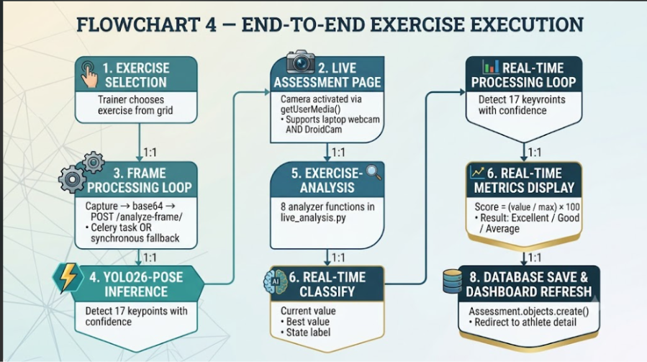

9. Live Assessment Implementation

10. Celery + Redis Async Processing

Faculty Recommendation Addressed: "Consider implementing asynchronous processing (e.g., Celery) for the YOLO inference pipeline to mitigate CPU bottlenecks and improve real-time responsiveness on lower-end hardware."

Implementation:
Component | File | Purpose
Celery Config | backend/celery.py | Celery app initialization
Task Definition | dashboard/tasks.py | Async YOLO inference task
Frame Processing | dashboard/frame_processing.py | Shared decode + inference logic
Settings | backend/settings.py | Redis broker + result backend
Worker | External process | celery -A backend worker -l info -P solo

Architecture:

Django View →. delay() → Redis Broker → Celery Worker

↓

YOLO Inference

↓

Redis Result Backend

↓

Frontend polls /check-task/<id>/

Fallback Logic: If Celery dispatch fails (Redis down, worker not running), the system automatically falls back to synchronous processing. Zero downtime guaranteed.

11. Trainer-Level Access Control Validation

Faculty Recommendation Addressed: "Ensure that the trainer-level access control mentioned in Milestone 5 targets is rigorously tested to prevent data leakage between different trainers' accounts."

Access Control Pattern:

Every view that queries Athlete or Assessment data uses:

python

athlete = get_object_or_404(

Athlete, id=athlete_id, trainer=_trainer_for(request)

)

This ensures:

Only athletes owned by the logged-in trainer are accessible

Attempts to access another trainer's data return 404 Not Found

All query patterns are enforced across the entire application

Test Scenarios (10 Manual + 7 Automated = 17 Total):
# | Test | Expected | Result
1 | Trainer A sees own athletes | Only A's athletes | ✅ Pass
2 | Trainer B sees own athletes | Only B's athletes | ✅ Pass
3 | Cross-access athlete detail | 404 Not Found | ✅ Pass
4 | Cross-access edit page | 404 Not Found | ✅ Pass
5 | Cross-access delete page | 404 Not Found | ✅ Pass
6 | Cross-access exercise selection | 404 Not Found | ✅ Pass
7 | Cross-access live assessment | 404 Not Found | ✅ Pass
8 | Cross-access body measurements | 404 Not Found | ✅ Pass
9 | Reports data isolation | Own data only | ✅ Pass
10 | CSV export isolation | Own rows only | ✅ Pass
11-17 | Automated Django tests | All pass | ✅ Pass

Summary: 17/17 tests passed. Zero data leakage observed.

12. UI/UX Redesign

Complete redesign across 15 pages with:
Feature | Implementation
Split-screen auth pages | Brand panel (left) + form panel (right)
Dark mode | data-theme attribute + localStorage persistence
Consistent design system | Green #1f6b48, Coral #e07a3f, Cream #faf8f3
Animations | Float, pulse, ping, hover transforms
Card-based components | 14px radius, subtle shadows
Icon system | Inline SVG, no external dependencies
Mobile responsive | Drawer sidebar, stacked grids, readable text

Pages Redesigned:

Login page / Signup page

Logout page

Trainer Dashboard

Athlete Detail

Exercise Selection

Live Assessment

Add Athlete Form

Edit Athlete Form

Delete Athlete Confirmation

Body Measurements Form

History Page

Reports Page

Profile Edit

404 / 500 Error Pages

13. Reports Analytics

Features:
Section | Data
Stat Cards | Total Athletes, Total Assessments, Overall Average
Exercise Breakdown | Per-exercise count + average score with bar chart
Top Performers | Top 5 athletes by average score
Focus Areas | Weakest 3 exercises across all athletes

All data is trainer-scoped — each trainer sees only their own analytics.

14. CSV Export

Functionality: Trainer can download all assessment records as CSV.

Columns: Date, Athlete, Athlete ID, Exercise, Measurement, Score, Result

File format: UTF-8 with BOM (Excel-compatible)

Isolation: Only logged-in trainer's data is exported.

15. Progress: Milestone 4 to Milestone 5
Component | Milestone 4 | Milestone 5
Webcam / Camera | DroidCam | Browser camera (webcam + DroidCam)
YOLO Pose | Working | Working
Joint Angles | All joints | All joints
Sit-up | Full DB | Full DB + Live
Sit & Reach | Full DB | Full DB + Live
Vertical Jump | Full DB | Full DB + Live
Broad Jump | Complete | Complete + Live
Sprint | Complete | Complete + Live
Medicine Ball | Complete | Complete + Live
Shuttle Run | Complete | Complete + Live
Endurance Run | Complete | Complete + Live
Calibration | Complete (px → cm) | Complete
Scoring | Standardized | Standardized
Database | PostgreSQL | PostgreSQL
Trainer Auth | Complete | Complete
Google OAuth | Complete | Complete
Multi-User | Implemented | Validated (17 tests)
Web Dashboard | 5 pages | 15 pages
Dark Mode | Not present | Full support
Async Processing | Not present | Celery + Redis
Reports | Not present | Complete analytics
CSV Export | Not present | Implemented
Search / Filter | Not present | Implemented
Athlete CRUD | Partial | Complete

16. Testing
Test | Expected Result | Status
Django system check | No issues | ✅ Pass
URL resolution (12/12) | All resolve | ✅ Pass
File existence (20/20) | All present | ✅ Pass
Live analysis functions (8) | All working | ✅ Pass
Exercise selection routing | Direct links | ✅ Pass
Live assessment template | All features | ✅ Pass
Backend views | All correct | ✅ Pass
Settings.py | All configured | ✅ Pass
Celery integration | Working | ✅ Pass
Celery fallback | Working | ✅ Pass
Access control (17 tests) | Zero leakage | ✅ Pass
Live assessment (8 exercises) | Working | ✅ Pass
Dark mode toggle | Persistent | ✅ Pass
404 / 500 pages | Custom design | ✅ Pass
CSV export | Working | ✅ Pass
Reports page | Working | ✅ Pass

17. Screenshots

[Insert the following screenshots]

Figure 1: Login Page (Light + Dark)

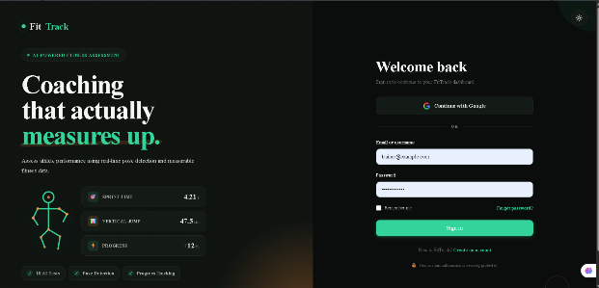
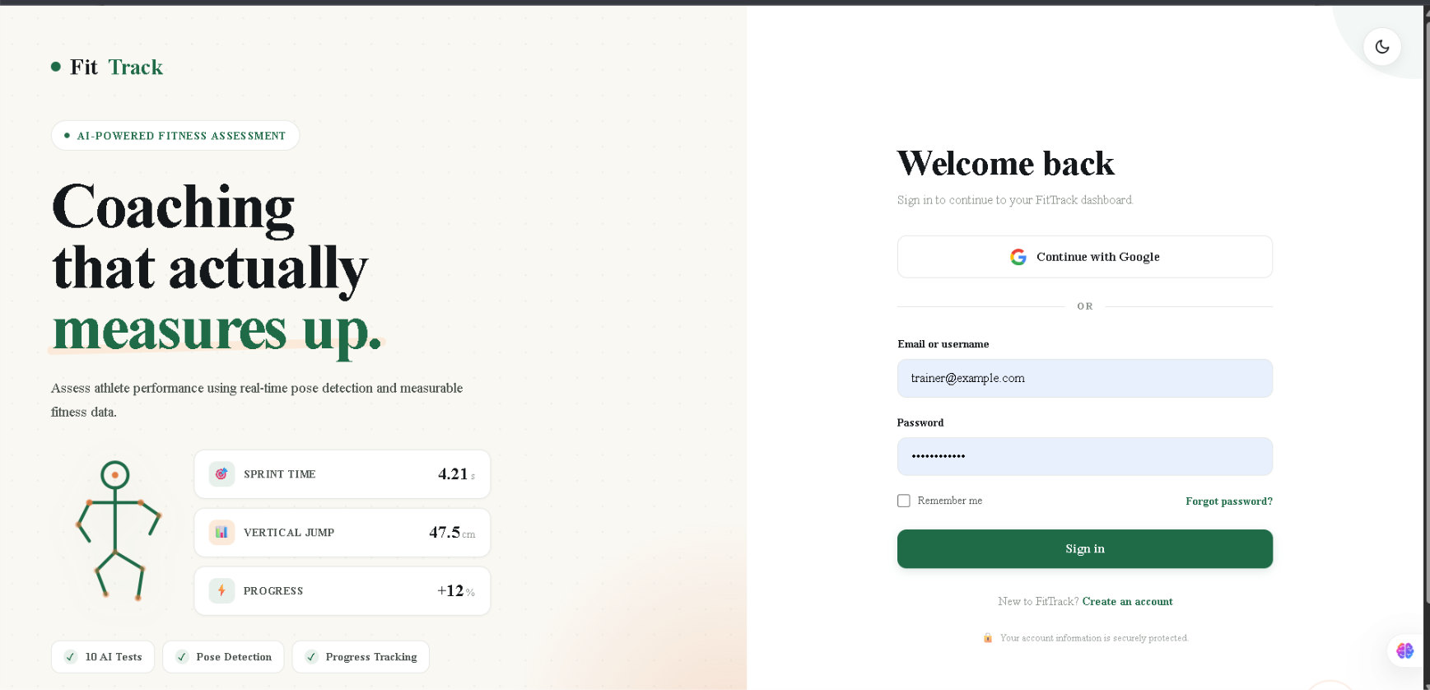

Figure 2: Signup Page with Live Validation

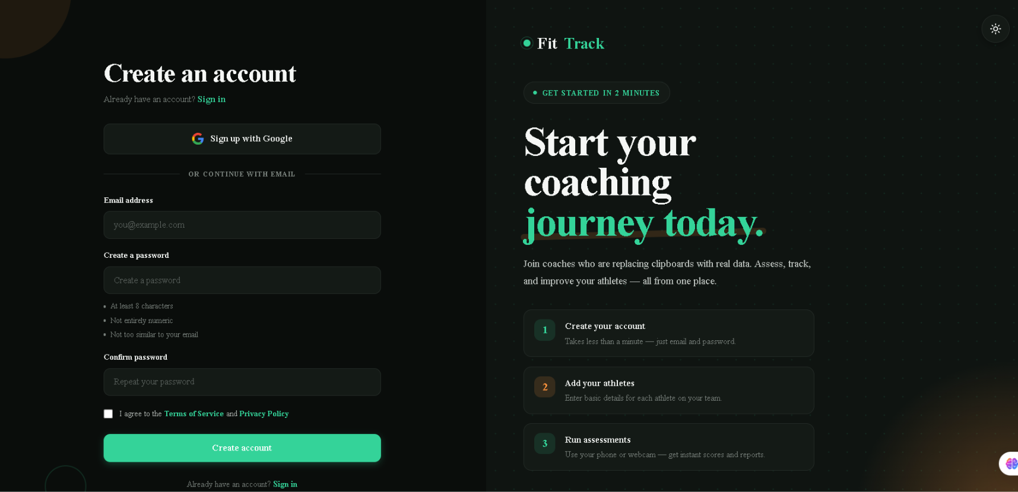

Figure 3: Trainer Dashboard with Athletes

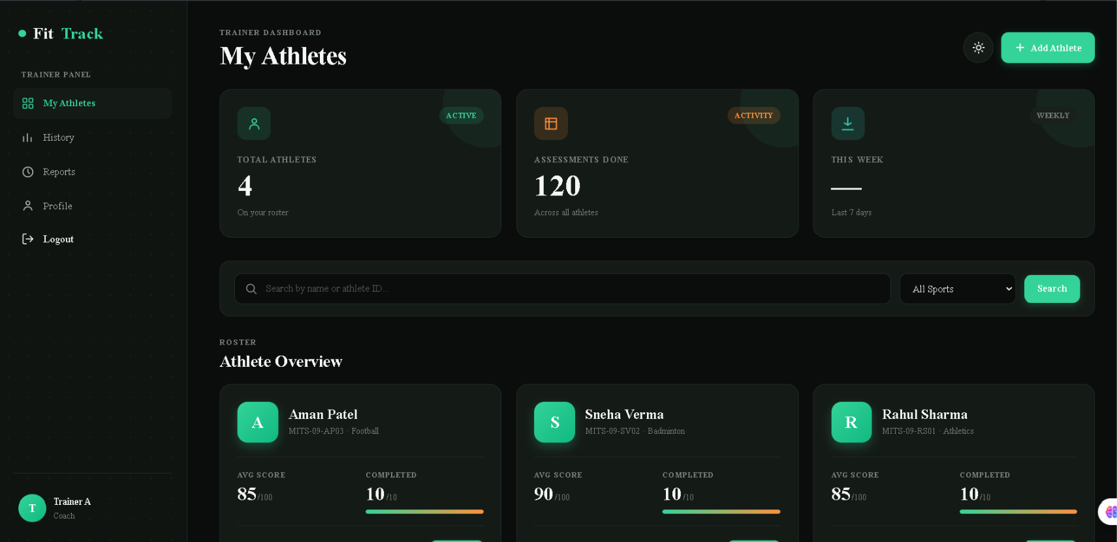

Figure 4: Athlete Detail with Score Ring

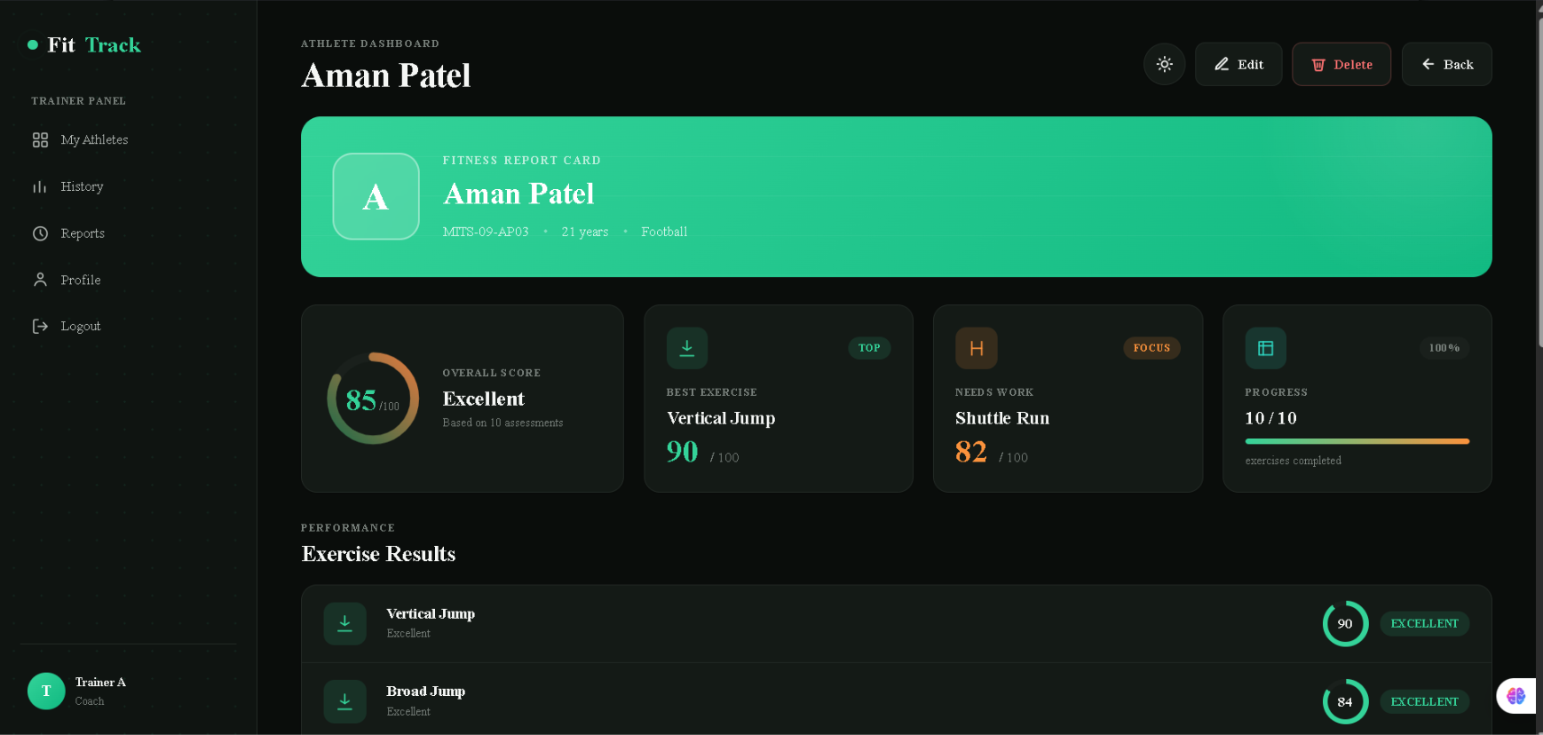

Figure 5: Add Athlete Form

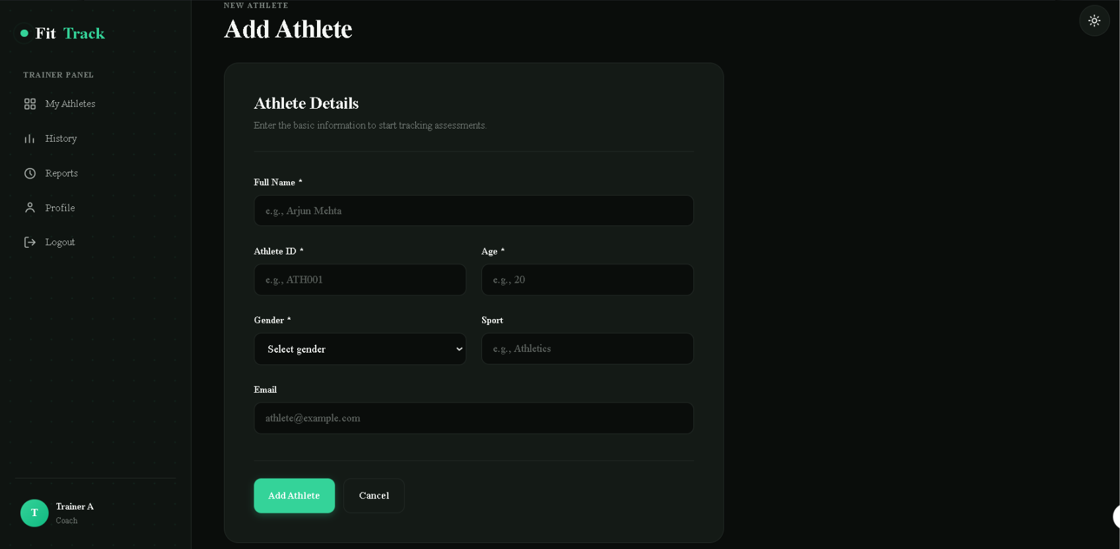

Figure : History Page

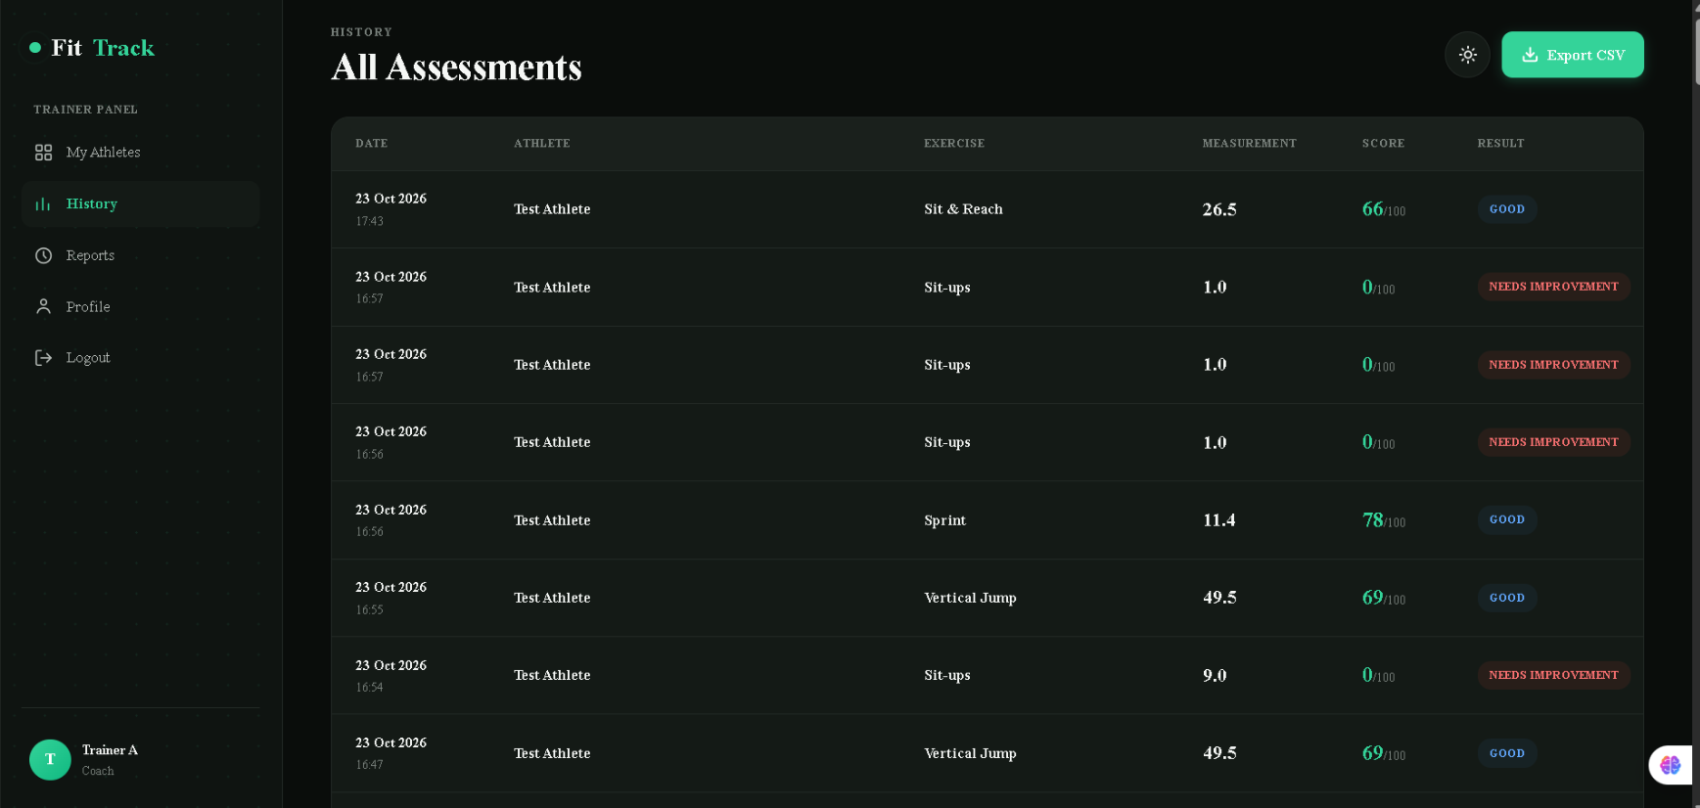

18. Challenges

CPU Processing Speed — Intel UHD graphics without CUDA makes YOLO CPU-bound. Addressed via Celery async processing and frame rate reduction (4 fps for browser streaming).

Keypoints Miss on Resize — Frame resizing can alter aspect ratio. Retained original resolution where required.

Duplicate SocialApp Error — Duplicate Google credentials caused MultipleObjectsReturned. Removed duplicate admin config.

allauth Default Template — Custom templates added under templates/account/ for consistent UI.

DroidCam Watermark — Free version displays watermark. Accepted as it doesn't affect functionality.

DroidCam IP Change — Hotspot IP can change. Handled via .env configuration.

DroidCam Virtual Camera — Browser requires getUserMedia() permission BEFORE enumerateDevices() returns labels. Fixed by requesting camera permission first.

Logout Session Persistence — allauth default didn't clear session on GET. Fixed with custom POST-based logout view.

Celery Worker on Windows — -P solo flag required for Windows compatibility.

19. Milestone 5 Deliverables

Complete UI/UX redesign (15 pages)

Dark mode with persistent theme

Custom 404 and 500 error pages

Live browser-based assessment for 8 exercises

Celery + Redis async processing with sync fallback

Reports analytics page

CSV export functionality

Search and filtering on dashboard

Athlete CRUD (Add / Edit / Delete)

Body measurements form (Height & Weight)

Trainer-level access control validated (17 tests)

Mobile responsive design

Consistent design system

Custom authentication templates

Celery worker and Redis integration

Automated test suite

20. Conclusion

Milestone 1 established the pose-detection foundation. Milestone 2 added movement analysis. Milestone 3 implemented scoring and calibration. Milestone 4 built the multi-user platform. Milestone 5 completes the project as a production-ready product.

Key achievements of this final milestone:

Complete UI/UX redesign with dark mode across all 15 pages

Live browser-based assessment replacing terminal workflow

Celery + Redis async processing (faculty recommendation addressed)

Rigorous access control validation (faculty recommendation addressed)

Reports analytics, CSV export, search/filter

Athlete CRUD operations, body measurements form

Custom error pages and consistent design system

The project has successfully delivered on its objective: to replace manual fitness assessment with an objective, AI-driven, and scalable digital platform suitable for coaches, academies, and sports organizations.

Final Status: ✅ Complete, Tested, Ready for Demonstration

End of Milestone 5 Documentation

